CUSTOMER PORTAL

Order Balance PHP 50,000.00
Account Balance PHP 75,000.00
INVENTORY LIST
MAKE ORDER

Order History:
Filtering: [10|25|50|100]
Document Number | Date | Amount
SO 5 | 05/01/2021 | PHP 50,000.00
RC 1 | 04/30/2021 | -PHP 25,000.00
SO 4 | 04/01/2021 | PHP 25,000.00
SO 3 | 03/01/2021 | PHP 25,000.00
SO 2 | 02/01/2021 | PHP 25,000.00
SO 1 | 01/01/2021 | PHP 25,000.00

INVENTORY LIST
MAKE ORDER

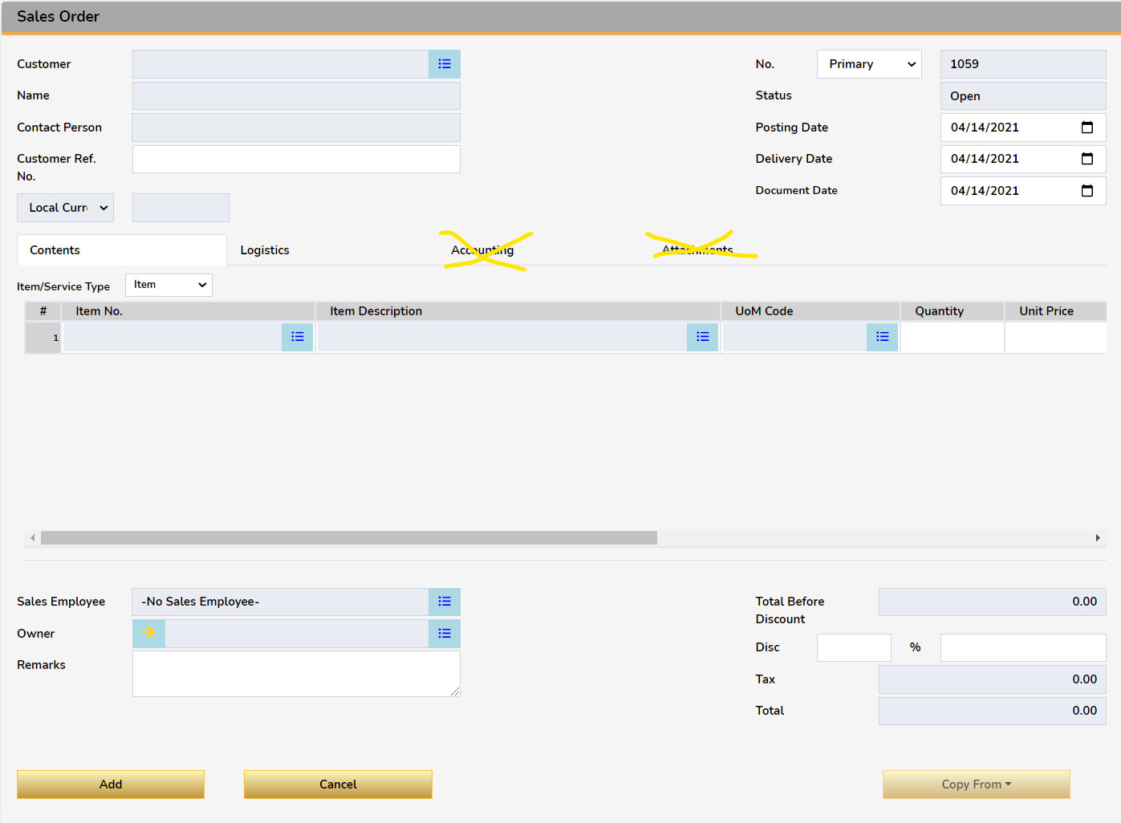
Login issues
- Isa pang external database
- Wag na ilabas list ng database,
- Cardcode ang user code

Additional Notes
rush before tuesday

-pricelist per item
-remove goldern on customer
-remove field owner replace mo ng null, ownercode set to null n lng
-discounts pakidisable
-unit price, disable mo
-tax code, hide mo
-net total hide mo
-hide UDF mo
-service type, disable mo
-sales employee, remove button ung nakadefault lng ang ilabas mo
-posting date and document - disabled, always current date
-hide currency
-paiksian mo ung itemcode column at ung description nya - wag na paikliin kasi sakto na bilang ng column sobra sa space
-copy from alisin mo
-bill to hide mo
-shipping type pwede wala laman depende sa default ni BP
-account balance when clicked, show modal of list of ar invoices tagged to logged in customer
-Ung in stock na column ang laman nya is ung instock minus committed sa OITW
pag nag negative dapat 0 lalabas.
-home button on SO, ITL
-change password on next log in, checkbox un User Management Module

